**Fire Extinguishers**

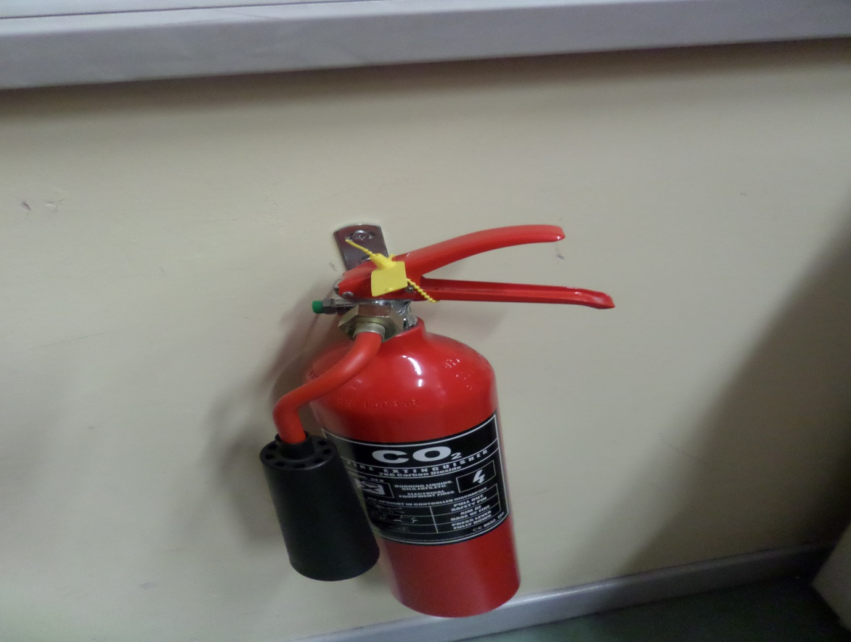

**Distribution of Fire Extinguishers throughout Institute**

This report lists off the numbers of fire extinguishers throughout the Departments of the Institute. The Looks at the total extinguishers in each of the departments throughout the 6 buildings of the Institute. Each of the Colleges , Arts, Engineering, Science and Business is looked at, Department by Department

This report was compiled in Q2 2014 by the QA Dept. of Health and Safety GOVHS according to regulation l178

For more information click here <http://bit.ly/1Nr178>

|  |  |  |  |  |  |  |  |
| --- | --- | --- | --- | --- | --- | --- | --- |
| Colleges |  | Buildings | 1 | 2 | 3 | 4 | Totals |
|  |  |  | Fire Extinguishers | | | |  |
| Arts | Departments |  |  |  |  |  |  |
|  | Literature |  | 10 | x | x | x |  |
|  | Languages |  | x | 5 | x | x |  |
|  | Music |  | 8 | x | x | x |  |
|  | Philosophy |  | x | 6 | x | x |  |
| Subtotals |  |  | 18 | 11 | 0 | 0 | 29 |
| Engineering | Departments |  |  |  |  |  |  |
|  | Civil |  | x | x | 4 |  |  |
|  | Mechanical |  | x | x | x |  |  |
|  | Electrical |  | x | x | 4 |  |  |
|  | Control |  | x | x | 4 |  |  |
| Subtotals |  |  | 0 | 0 | 12 | 0 | 12 |
| Science | Departments |  |  |  |  |  |  |
|  | Physics |  | x | x | x | 6 |  |
|  | Chemistry |  | x | x | x | 6 |  |
|  | Maths |  | x | x | x | 6 |  |
|  | Computers |  | x | x | 4 | 4 |  |
|  | Biology |  | x | x | x | 6 |  |
| Subtotals |  |  | 0 | 0 | 4 | 22 | 28 |
| Business | Departments |  | Note Business School under renovation | | | |  |
|  | Marketing |  | x | x | x | x |  |
|  | Commerce |  | x | x | x | x |  |
|  | e-commerce |  | x | x | x | x |  |
|  | Accountancy |  | x | x | x | x |  |
| Subtotals |  |  | 0 | 0 | 0 | 0 | 0 |
|  |  |  |  |  |  |  |  |
| Totals |  |  | 18 | 11 | 16 | 22 | 113 |
|  |  |  |  |  |  |  |  |